**NAB Shopping App**

A small shopping application has built by jhipster, spring, hibernate, ehcache... And designed as monolithic app.

Technology stack on the client side

* Angular
* Responsive web design with bootstrap
* Optional Sass support for CSS design

Technology stack on the server side

* Spring boot for application configuration
* Maven config for building/testing/running the NAB application
* Spring Security
* Spring MVC Rest + Jackson
* Database updates with liquibase
* Caching with ehcache (local cache)

**Resource Coding:**

<https://github.com/trilm60200/nbashoppingcart.git>

Please refer README.md to know how to build/deploy/test.

**Entity Relationship:**

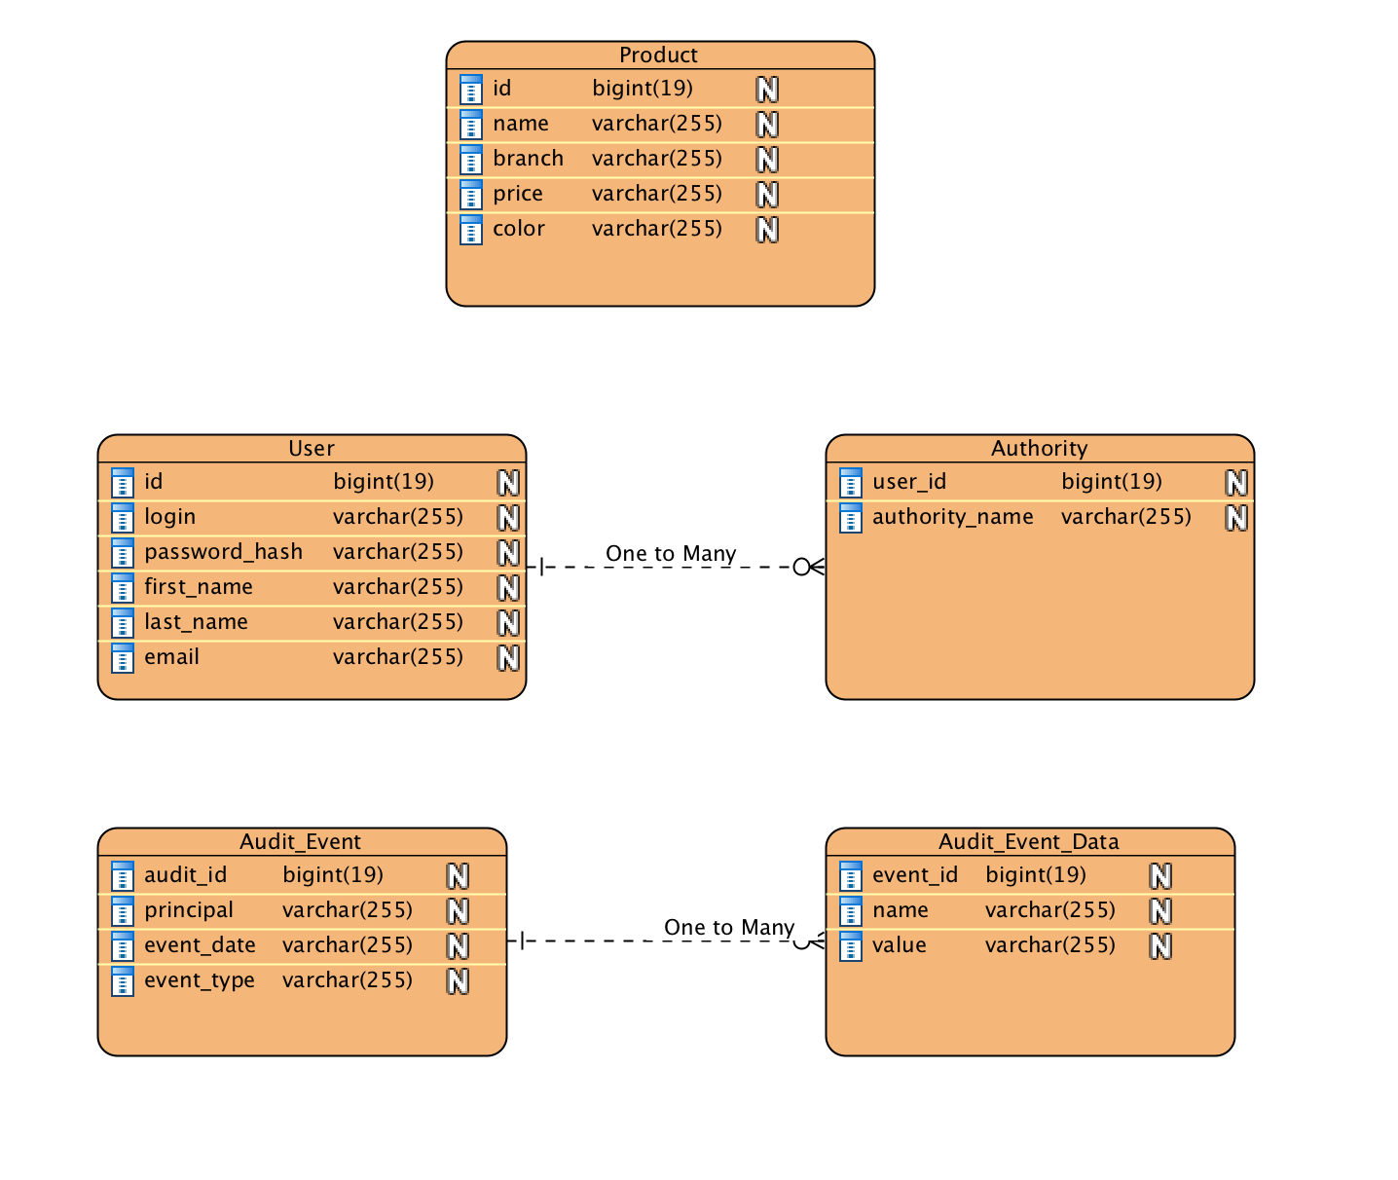

**Coding folder structure:**

1/ Backend Files:

* The Java code is contained in the src/main/java folder
* The src/main/resources folder has some of the static content used by the Java code
* Unit and integration tests are located in the src/test/java folder
* Interface and Implementation are inside /service , controller (resource) is inside web.rest

2/ Frontend:

* The root front end folder is *src/main/webapp*
* The *app* folder contains much of the AngularJS modules

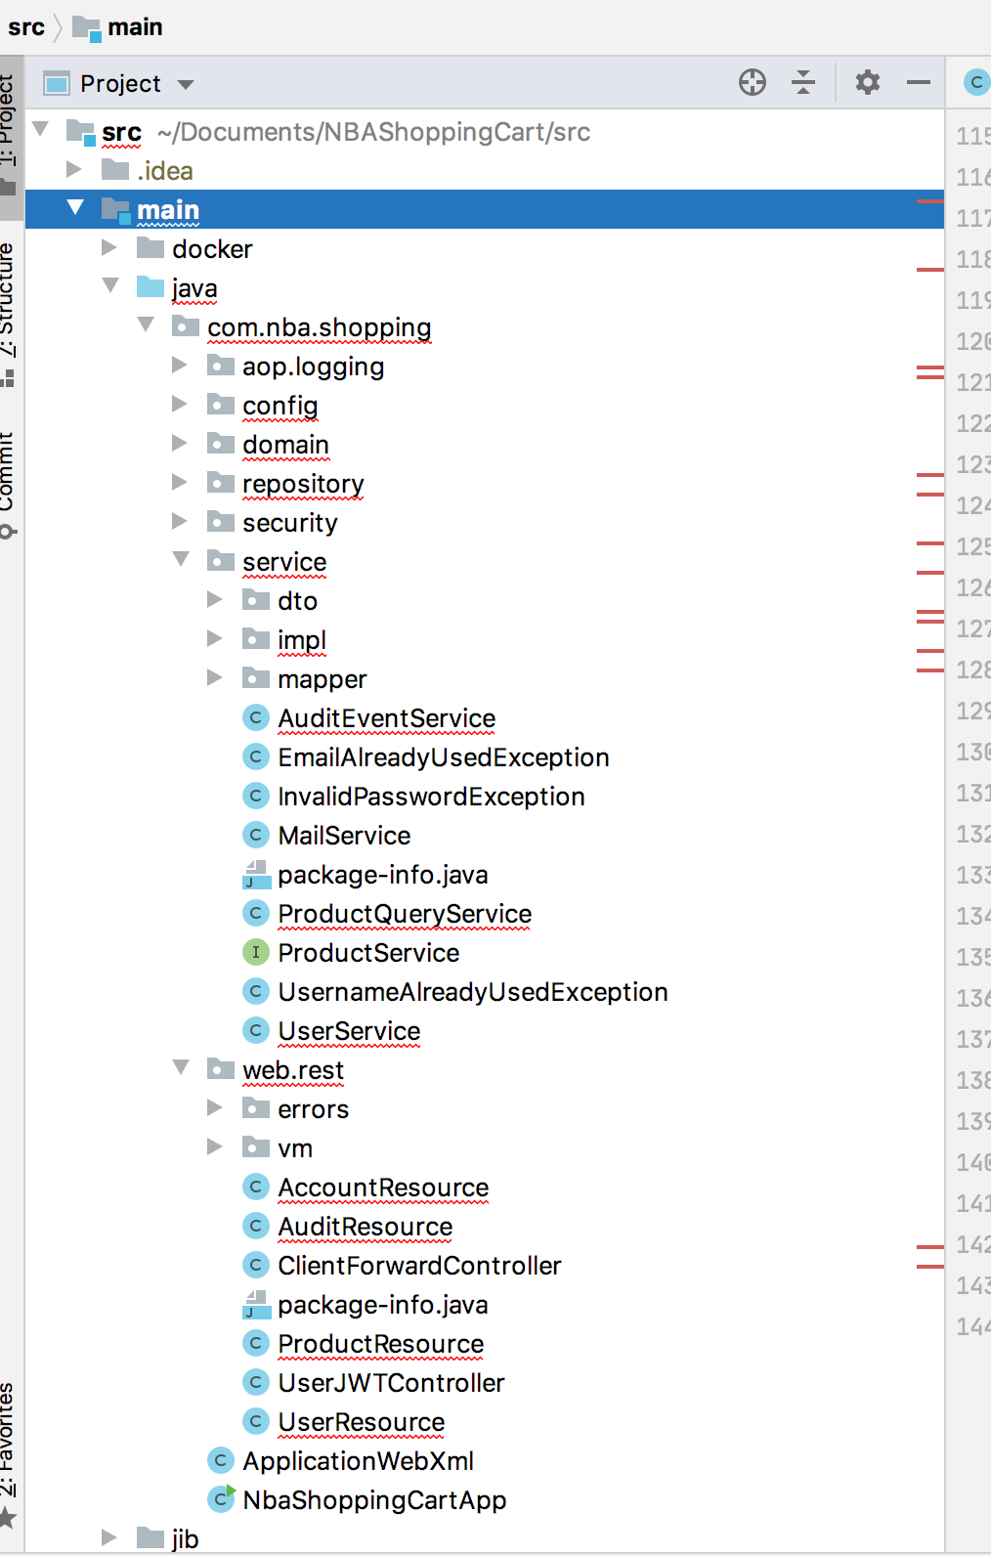

**How to Run:**

Before you can build this project, you must install and configure the following dependencies on your machine:

[Node.js][]: We use Node to run a development web server and build the project.

After installing Node, you should be able to run the following command to install development tools.

**npm install**

Run the following commands in two separate terminals to create a blissful development experience where your browser auto-refreshes when files change on your hard drive.

**./mvnw**

**User Guide**

**For shopping:**

Client could register a new user or reuse default account: user/user

**For monitoring:**

Please login as admin/admin. IT helpdesk could go to Administartor navbar

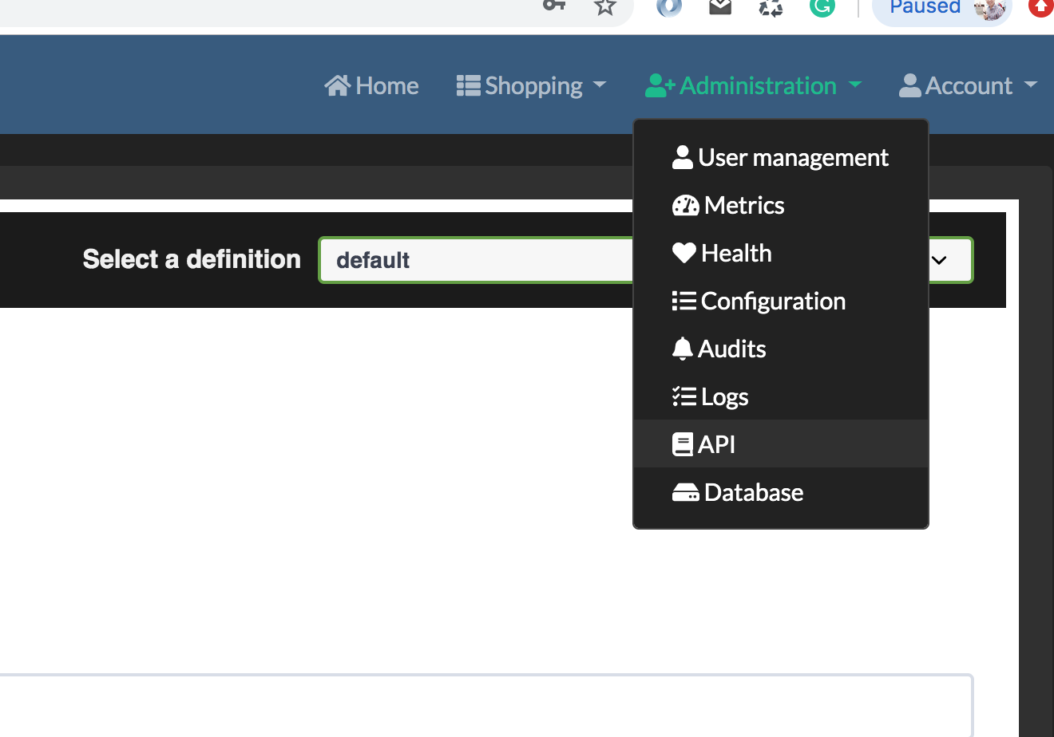

- View the logs: <http://localhost:8080/admin/audits>

- View/Test the APIs: <http://localhost:8080/admin/docs>

(build by swagger)

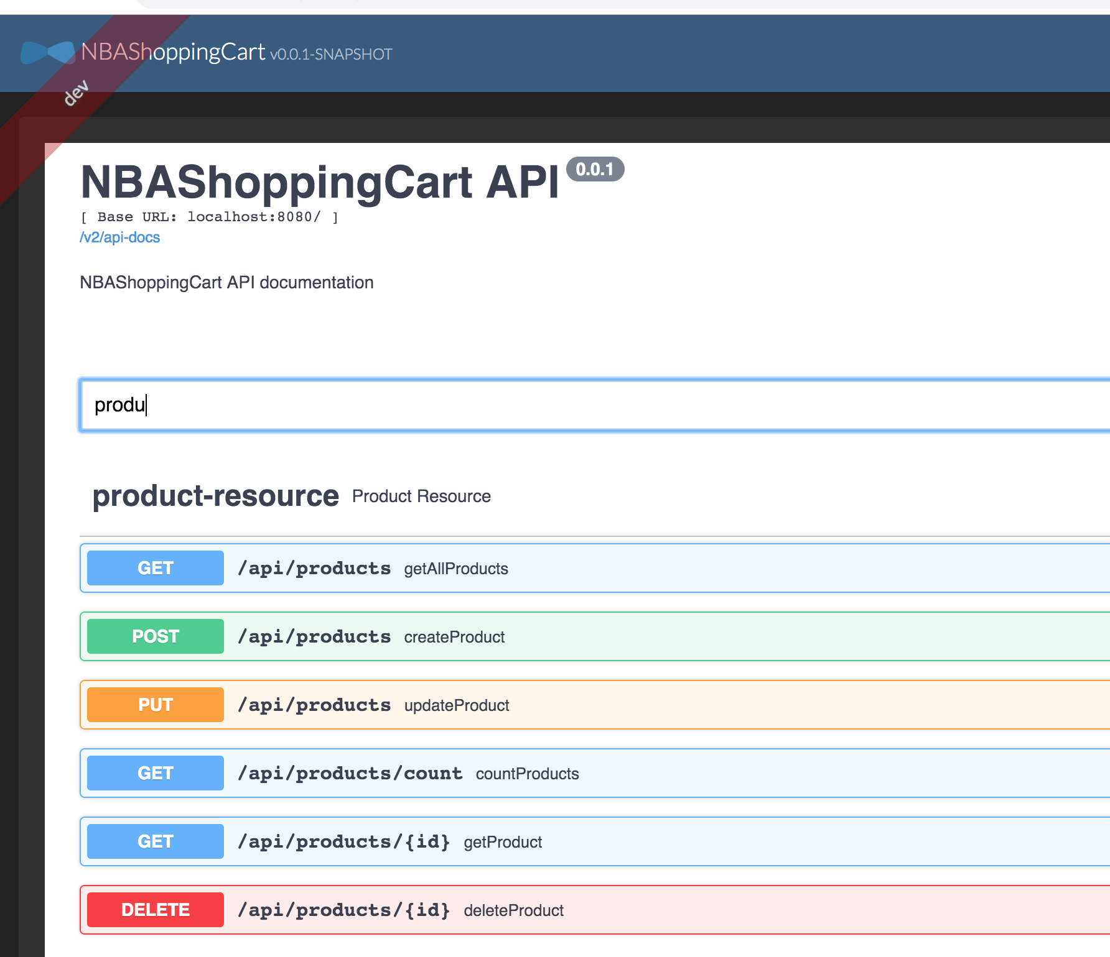

- Monitor in-memory DB: <http://localhost:8080/h2-console/login.jsp?jsessionid=fdc0e0f87115ce7cafe2cd1527f03a86>

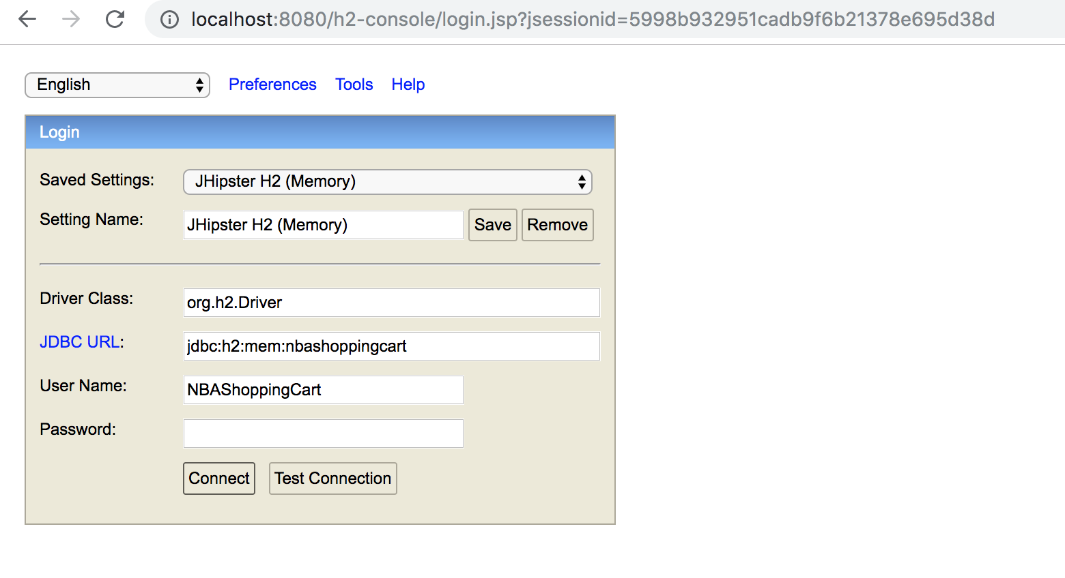

Click “Connect”

